**Exercise 4: Creating and Configuring a Maven Project**

1. BookRepository.java

package com.library.repository;  
  
public class BookRepository {  
 public void displayBooks() {  
// System.out.println("📚 Showing all books from repository...");  
 System.*out*.println("📚 Displaying all books...");  
 }  
}

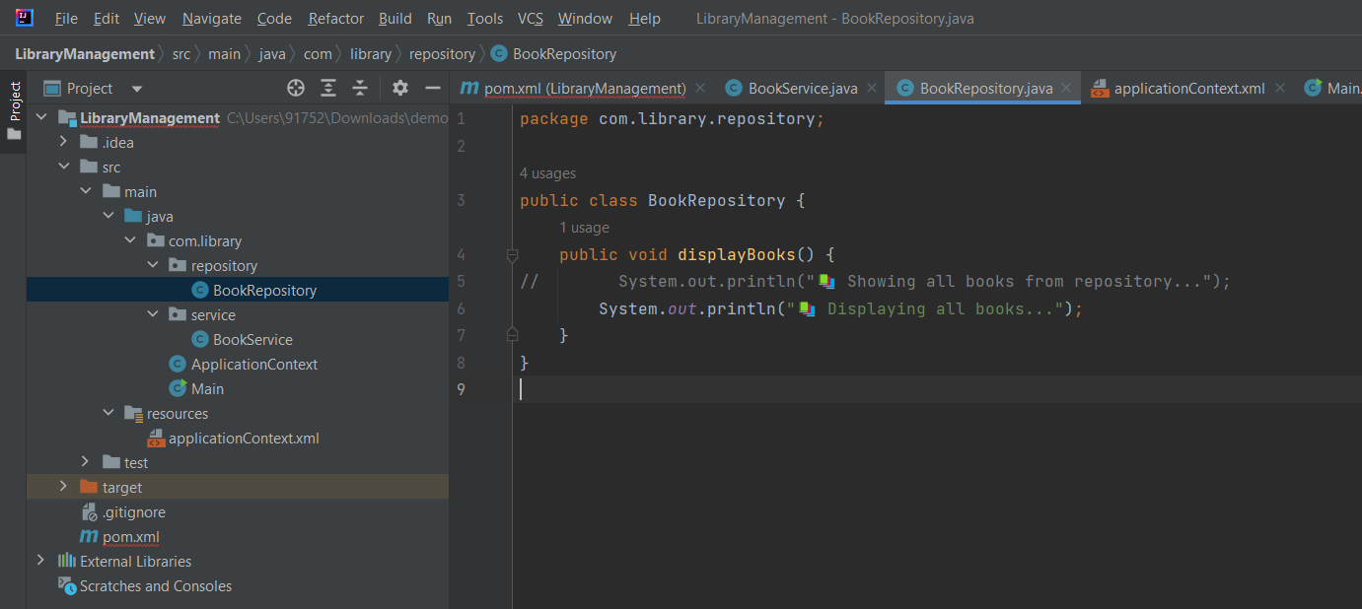

2

BookServoce.java

package com.library.service;  
  
import com.library.repository.BookRepository;  
  
public class BookService {  
 private BookRepository bookRepository;  
  
 // ✅ Setter for DI  
 public void setBookRepository(BookRepository bookRepository) {  
 this.bookRepository = bookRepository;  
 }  
  
 public void showBooks() {  
 bookRepository.displayBooks(); // call repo method  
 }  
}

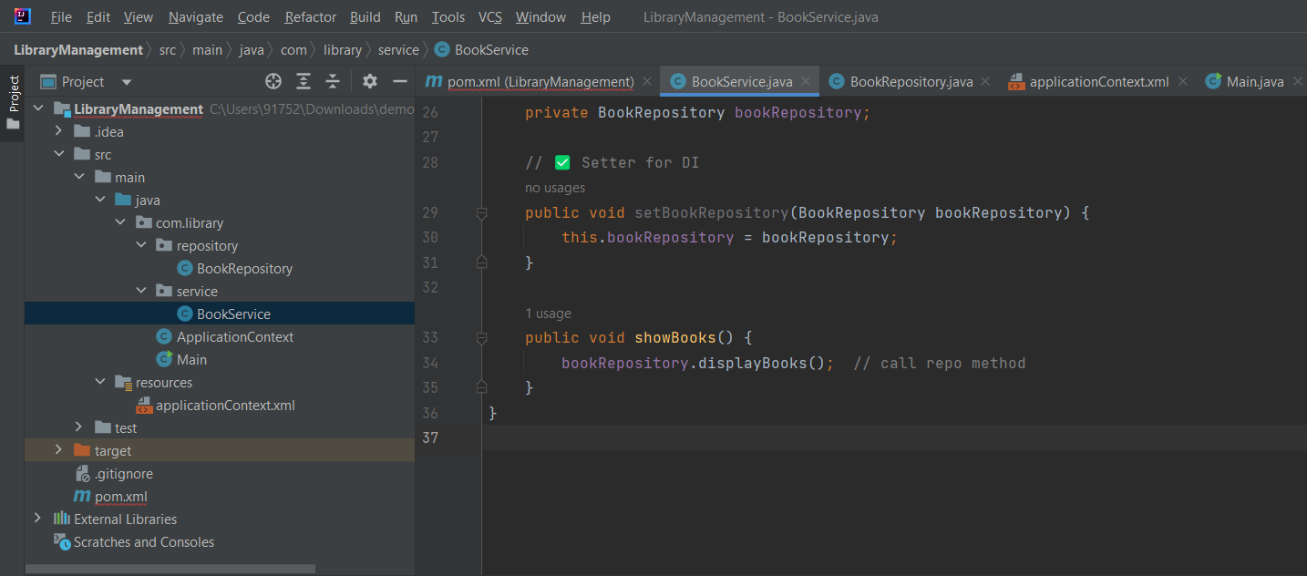

3-a[[locationContext.xml

<?xml version="1.0" encoding="UTF-8"?>  
<beans xmlns="http://www.springframework.org/schema/beans"  
 xmlns:xsi="http://www.w3.org/2001/XMLSchema-instance"  
 xsi:schemaLocation="  
 http://www.springframework.org/schema/beans  
 http://www.springframework.org/schema/beans/spring-beans.xsd  
http://www.springframework.org/schema/beans  
http://www.springframework.org/schema/beans ">  
  
 <!-- ✅ BookRepository Bean -->  
 <bean id="bookRepository" class="com.library.repository.BookRepository"/>  
  
 <!-- ✅ BookService Bean with injected repository -->  
 <bean id="bookService" class="com.library.service.BookService">  
 <property name="bookRepository" ref="bookRepository"/>  
 </bean>  
  
</beans>

**Output-**

